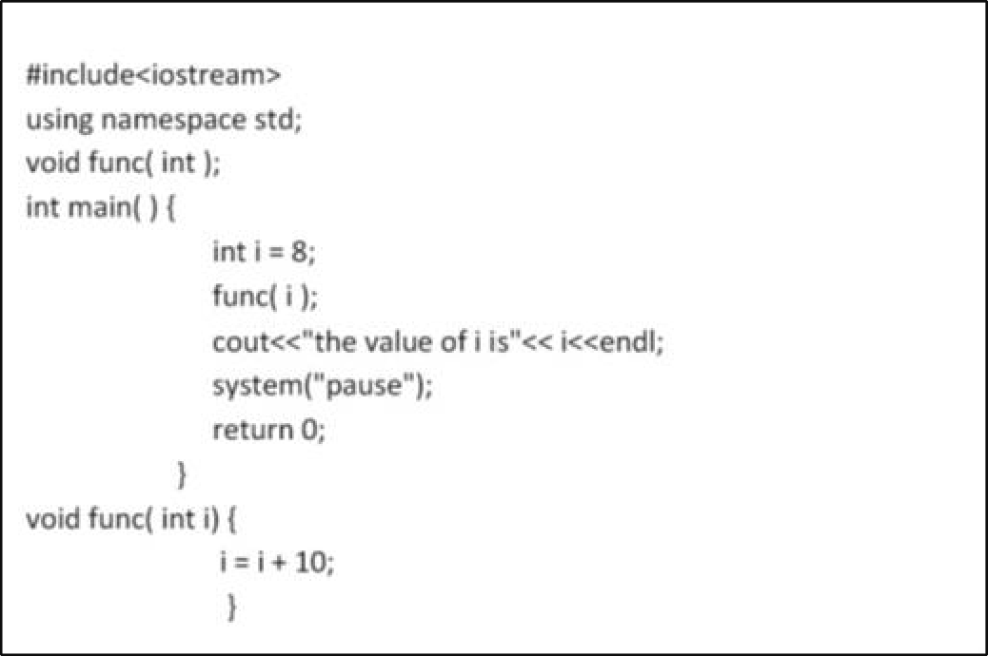

Lab No: 10

✵ Lab Title: Functions (Part II)
- Learning objectives:
The following topics will be covered in this lab session
  - Function Call by Value
  - Function Call by Reference
  - Default values in parameters
  - Random Number generation


Calling Functions:

- Call by Value:

Call by value is used when whenever the called function does not need to modify the value of the caller’s original variable. In this case a copy of the variable is passed to the function and when the function changes its values then it has no effect on the value of the variable in the main function.
- Program:

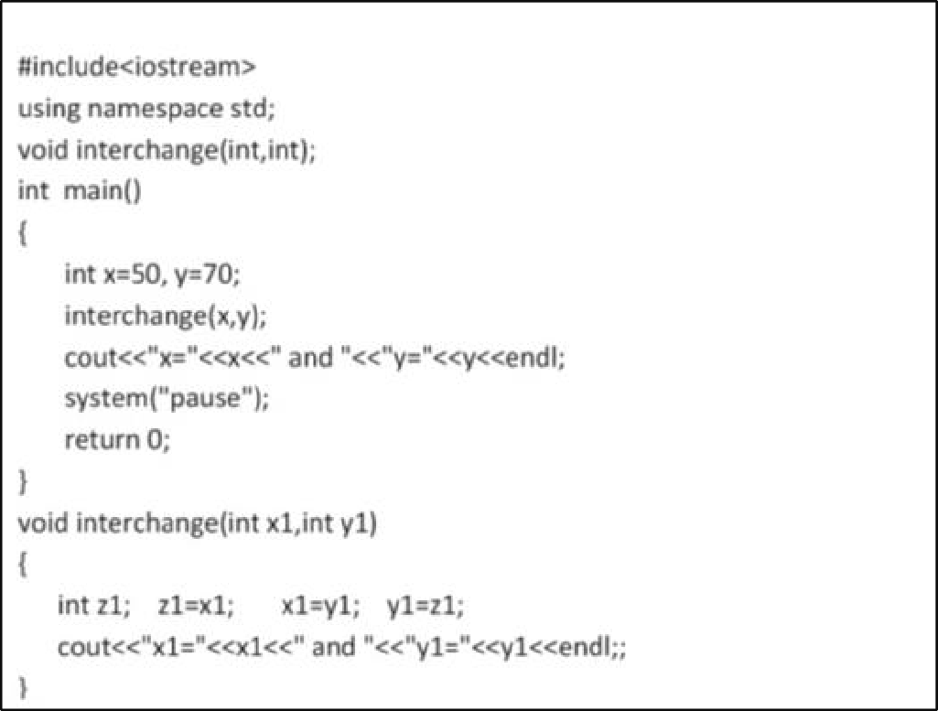

- Program:


- Output:

Call by Reference:

If you are calling by reference, it means that compiler will not create a local copy of the variable which you are referencing to. It will get access to the memory where the variable saved. When you are doing any operations with a referenced variable you can change the value of the variable.

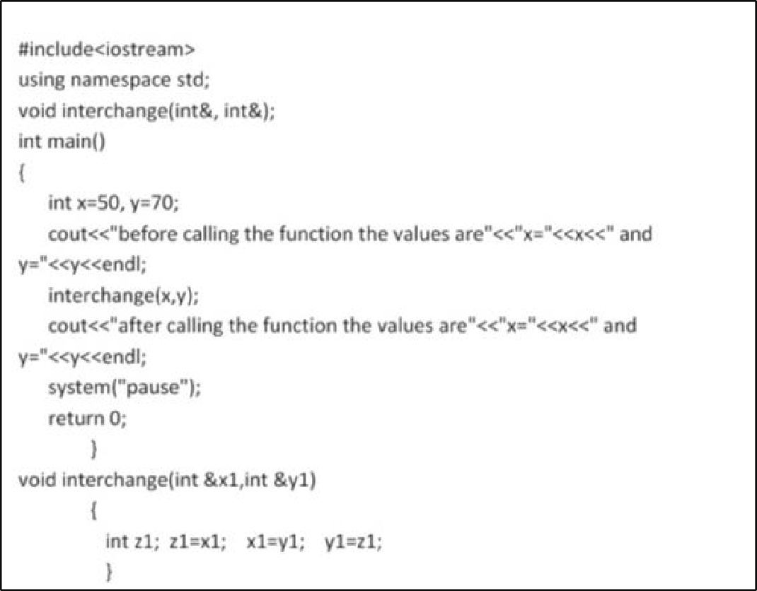

- program:


Here the function is called by reference. In other words, address is passed by using symbol “&” and the value is accessed by using symbol “*”.
The main difference between them can be seen by analysing the output of program1 and program2. The output of Example 2 that is call by value is

But the output of Example 3 that is call by reference is

This is because in case of call by value the value is passed to function named as interchange and there the value got interchanged and got printed as
x1=70 y1=50

and again since no values are returned back and therefore original values of x and y as in main function namely

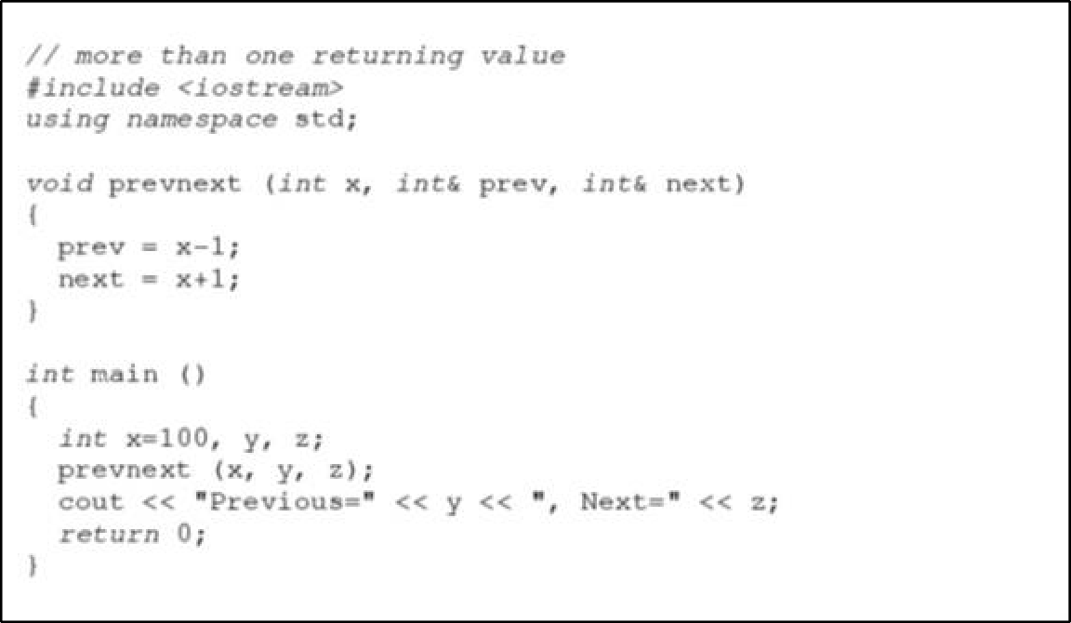

x=50 y=70 got printed.

Passing by reference is also an effective way to allow a function to return more than one value. For example, here is a function that returns the previous and next numbers of the first parameter passed.


Output:

Previous=99, Next=101

Default values in parameters:

When declaring a function, we can specify a default value for each of the last parameters. This value will be used if the corresponding argument is left blank when calling to the function. To do that, we simply have to use the assignment operator and a value for the arguments in the function declaration. If a value for that parameter is not passed when the function is called, the default value is used, but if a value is specified this default value is ignored and the passed value is used instead.

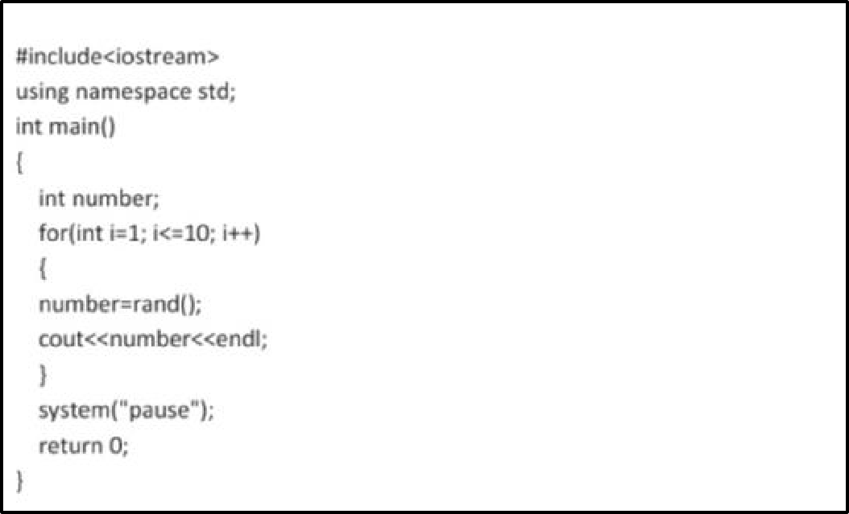


Output:


6

5

Random Number Generation:

rand () function is used for generating random numbers. This function is defined in standard library of
C. The output of the rand () function could be in the range of 0 to 32767 which is the upper limit for an integer.

Lab Tasks

- Task 1: Function with Parameters


Input:
#include <iostream> // input/output ke liye library
using namespace std; // std namespace use kar rahe hain
// function declaration (2 integer parameters) void multiply(int num1, int num2)
{
int result = num1 * num2; // dono numbers ka product calculate kiya
cout << "Multiplication = " << result << endl;
// result screen par display kiya
}

int main()
{
multiply(5, 4); // function call → 5 aur 4 pass kiye

return 0; // program end
}

- Output:
- Declare a function called "multiply" that takes two integer parameters: "num1" and "num2".
- Inside the function, calculate the product of the two numbers.
- Display the result within the function.
- Call the function from the main program, passing two numbers, to perform the multiplication.





  - Task 2: Function with Return Value
    - Declare a function called "getSquare" that takes an integer parameter: "number".
    - Inside the function, calculate the square of the number.
    - Return the result.
    - Call the function from the main program, passing a number, and display the square.




Input:
#include <iostream> // input/output library using namespace std; // standard namespace

// function declaration (integer return karega) int getSquare(int number)
{
int square = number * number; // number ka square calculate kiya
return square; // result wapas main function ko return kiya
\}

int main()
{
int result; // variable result store karne ke liye result = getSquare(7); // function call →7 pass kiya
cout << "Square = " << result << endl;
// result display kiya

return 0; // program end
}


Output:

Conclusion
In this lab, we learned different types of functions in C++ and how parameters are passed using call by value and call by reference. We also implemented functions with return values and default parameters. These concepts are essential for writing efficient and modular programs. Call by reference is useful when we need to modify original data, while call by value is safer when we want to protect original variables.

